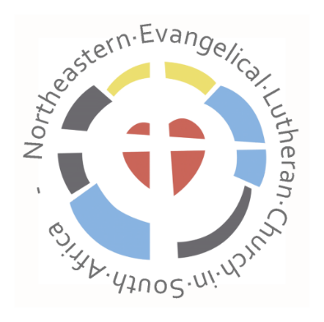
Bishops Post
Romans 5, 1 -5
5 Therefore, since we have been justified through faith, we have peace with God through our Lord Jesus Christ, ² through whom we have gained access by faith into this grace in which we now stand. And we boast in the hope of the glory of God. ³ Not only so, but we also glory in our sufferings, because we know that suffering produces perseverance; ⁴ perseverance, character; and character, hope. ⁵ And hope does not put us to shame, because God’s love has been poured out into our hearts through the Holy Spirit, who has been given to us. 5 Therefore, since we have been justified through faith, we have peace with God through our Lord Jesus Christ, ² through whom we have gained access by faith into this grace in which we now stand.
We have peace with God.
‘We have peace with God’ Paul writes to the Christians in Rome. The common western definition of peace is the absence of conflict or war or the absence of tension and fear, but in Hebrew it means so much more. It means harmony, wholeness, completeness, prosperity, welfare, and tranquillity.
Through Jesus Christ we have peace with God. This is what we believe. This is our faith and the foundation of our Christian hope.
As Christians we live in the grace of God.
Grace is like a protected space. We are accepted by God. We are forgiven. We need not to fear.
The first Christians that Paul writes to did not see grace as something that happened only between God and me. It was also something that they lived out amongst themselves. We can read about this in many places in the New Testament. Rich and poor, slave and free worshipped together. Hospitality was very important; the poor were cared for as much as possible and conflicts were solved peacefully as often as was possible. Christians helped one another to bear what was too difficult for one person alone.
How can we proclaim hope, peace, and grace in the times that we live in today? Should we not rather admit that the situation in which we live is hopeless. Many people have no hope for our country. We experience corruption and lawlessness every day. The economy is suffering due to loadshedding. How can one talk about hope, peace, and grace in a time like this?
Paul knows the objections to the words – we have peace. We have grace. We have hope. He writes: ³ Not only so, but we also glory in our sufferings, because we know that suffering produces perseverance; ⁴ perseverance, character; and character, hope.
Hope in God. Hope that trusts in God. It knows that crises will come. But it also knows that God will go with us. He will pour out his love on us and his Holy Spirit will lead us.
⁵ And hope does not put us to shame, because God’s love has been poured out into our hearts through the Holy Spirit, who has been given to us.
I close with a quote from an unknown author:
Faith, in defiance of resignation.
Hope, in spite of the circumstances.
Action, in spite of fear.
Living, in spite of worry.

News from the NELCSA
After a long time where very little contact took place the bishops of the ELCSA, NELCSA and ELCSA (Cape Church) met again on the 27th and 28th of April after a request from the ELCSA to do so. It was an informative meeting in good spirit, where the leaders of the three churches took time to get to know one another. It was also decided that the bishops would meet twice a year in the future.
The NELCSA choir festival took place on the 30th of April in the Johannesgemeinde in Pretoria. Choirs from various congregations of our church took part in a celebration of music. We thank God that such meetings are again possible again after the long period of forced isolation due the Covid-19.
The NELCSA is part of the Lutheran World Federation. The Lutheran World Federation is a global communion of 149 churches in the Lutheran tradition, representing over 77 million Christians in 99 countries. The Assembly as the highest governing body of the Lutheran World Federation meets every six years at a venue chosen by its Council based on invitations received from its member churches. The Assembly gathers representatives of its member churches, international ecumenical and church organizations, partner agencies from the development and mission fields, guests, the media, and others. The hosting church in Poland for the year 2023 is the Evangelical Church of the Augsburg Confession in Poland. We pray for God’s blessings for the time of preparation.
The ELCSA (Cape Church) and the NELCSA have been approached regarding a commission instituted by the Evangelical Lutheran Church in Hannover. The commission is investigating possible sexual misconduct and abuse of power by pastor Klaus Vollmer. Due to the fact the pastor Vollmer was also active in South Africa anyone who was involved with Pastor Klaus Vollmer and would like to approach the commission of the church of Hannover is invited to do so at the email address: kommission-hannover@posteo.de
Those interested in more information can do so on the webpage of the Evangelische Geschwisterschaft e.v: (http://geschwisterschaft.de/ueber_uns/page28/page28.html)
Theo Jäckel

